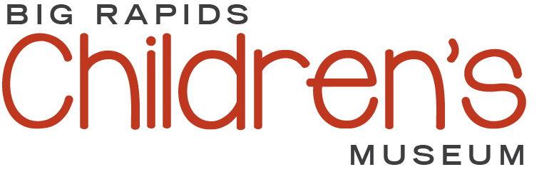

The Big Rapids Children’s Museum

Concept: Big Rapids needs a children’s museum. I discovered as a Grandmother in winter, 2023, that there are few indoor spaces to take my 2-year-old grandson to play and interact with others. My choices were limited to the Burger King play area, the indoor track at Ferris State University and numerous stores. We have a wonderful collection of parks which are great to use when weather permits.

We need an indoor hub where children of all ages can gather to learn, play, and grow. I propose that we create a children’s museum for Big Rapids which incorporates volunteers and businesses to build and maintain. I further propose that we start small and grow as demand and funds increase. As a grant writer myself, I have experience managing small community organizations as well as coordinating volunteers.

I have served on boards and am convinced that a small advisory board is best to start with for this initiative. I have created a checklist of needed action items and invite YOU to volunteer -since you have read this far! Please review with comment and return your thoughts to me at scain@corplearning.com. My direct reach is (630) 347-6333

I have started a checklist of actions needed to begin steps needed to explore this topic
In greater detail:

1. Create an advisory board to determine the interest and feasibility of a museum for children:

- Dr. Susan Cain
- Stacie Wright
- Lauren Perkins
- Josh Pyles
- YOUR NAME here!

Please nominate yourself or suggest others for us to contact:

Name Email or Phone

2. ..
- To determine interest, we need send a survey to:
- School board
- Healthcare organizations
- Ferris State University
- School administrators and/or teachers (including MOISD)
- Social welfare agencies
- Churches
- The Big Rapids Library
- City and county government
- Parent groups

Please suggest additional survey recipients:

Name (if known) Organization

3. ..
- To determine feasibility, we need to consider housing partnerships and funding sources:
- Contact Sandcastle Children’s Museum in Ludington for information and support. Investigate the possibility of a franchise relationship
- Contact the Grand Rapids Children’s Museum for information and support. Investigate the possibility of a franchise relationship
- Ferris State University
- Research potential housing partnerships with existing community-based organizations
- Survey businesses and/or governmental organizations for sponsorship
- Locate grants and donation sources

Please suggest additional contacts:

Name (if known) Organization

4. ..
- To tap into mentorship and support, we need to contact:

- Michigan Arts & Culture Council
- Association of Children’s Museums
- Museums for All
- Michigan Museums’ Association
- Association of Midwest Museums

Please indicate what you are willing to do to move this conversation forward:

Your name:
Your contact:
Volunteer interest:

Thank you for taking the time to read and review my initial thoughts on this important topic. Please send this completed document to:

Dr. Susan Cain
scain@corplearning.com

