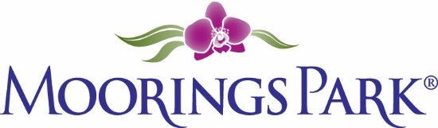
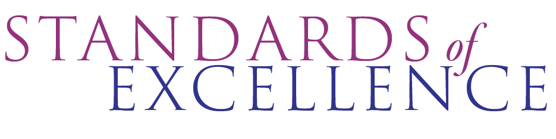
Moorings Park Standards of Excellence Project
Special Project Update
Date: 10-13-22
Website: https://www.corplearning.com/mp-standards/

Update | Comments | Action Steps
Moorings Park “Book” Review
Progress made on project website
Progress made on use of recommended survey and software
Core group members brainstorm
Task force member brainstorm

Other

