Moorings Park Special Projects

Discovery Brief

Table of Contents

Table of Contents
Background………………………………………………………………………
Summary Page……………………………………………………………
Partner Survey Data……………………………………………………..
Benchmarked Organizations ………………………………………......
Key Findings………………….……………….…………
Recommendations.…………………………..….………………………

Background
The Standards of Excellence Project Overview
We were asked to:

Overview of Project
The purpose of this report is to …

Summary of Findings and Implications
Below is a summary of our findings:
Partner Survey Data

The ultimate goal of this section is to identify true insights instead of simply reporting the facts is to inform the project….

Question 1.

Question 2.

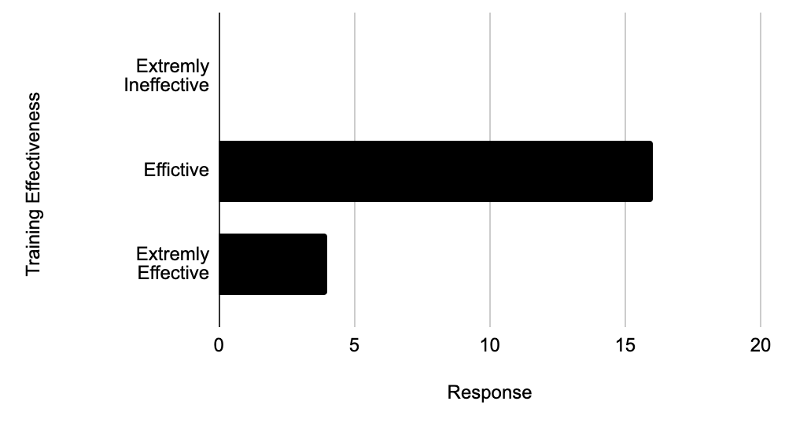

Graph 1:

Benchmarked Organizations and Key Findings

Recommendations
Recommendations:

This report is a product of hundreds of hours of interviewing, data compilation and review. Thank you to everyone at Moorings Park for your contributions.

