Understanding Others Worksheet
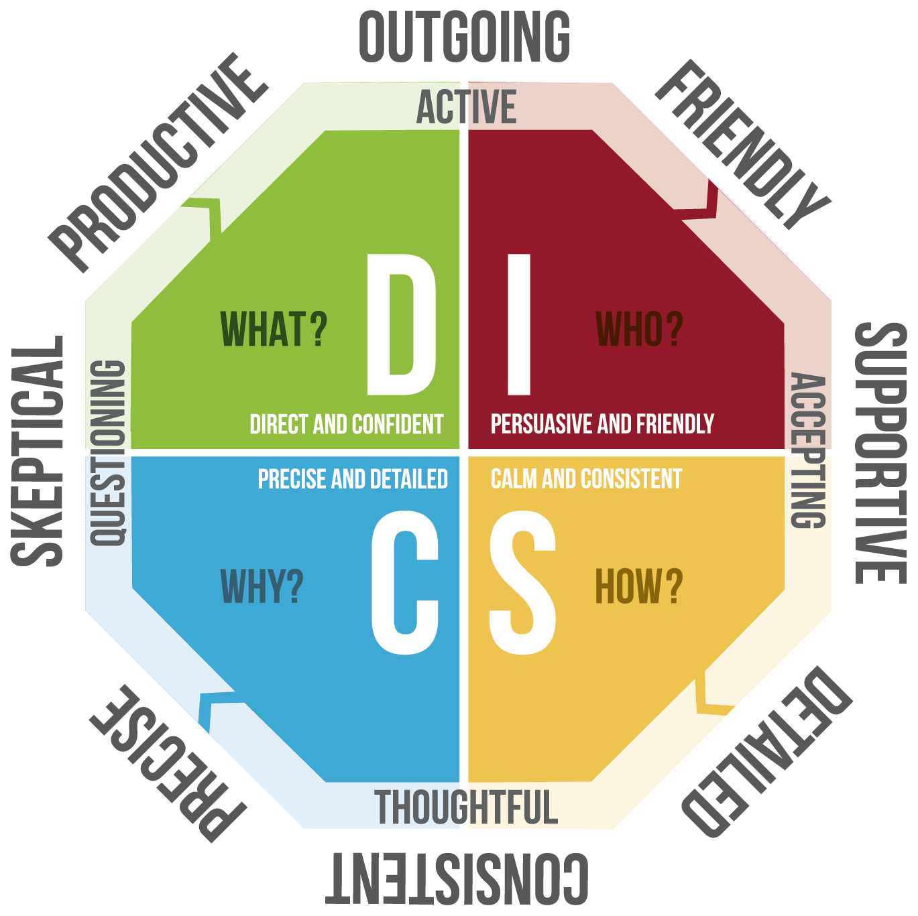
Understanding others using DISC is a helpful way of identifying preferences and responding effectively. Instead of boxing people into DISC profiles, consider using this guide as a way of increasing your appreciation for the style strengths and support needs another person has.

1. Identify a person you want to learn to appreciate more:

2. Consider how this person shows up:

Active (D, I ) or thoughtful and reserved (S,C)?
Questioning (C, D) or accepting? (I, S)?

- Productive and outgoing (D)?
- Outgoing and friendly (I)?
- Supportive and detailed and consistent (S)?
- Precise and skeptical?
- 3. Your best DISC style guess:
- DISC style strengths:
- DISC style challenges:
- Ways you can support this person to improve collaboration:

