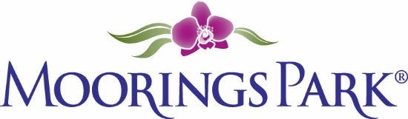
Moorings Park Weekly Progress Report
Week of 02/25/22 2022
Training Content | Complete | In Progress | Detail
CLI Updates? MP Updates?
1. Participant workbook in for typesetting |  | X | Editing and final review Monday
2. Manager Training Session up for review |  | X | Ready for one last edit and review before topsetting
3. All PowerPoints in production: participant, manager, trainer |  | X
4. All classroom materials sent for ordering | X
5. William/Steve updates |  | X
6. Finished materials available on 3-01-22
7. Next steps

