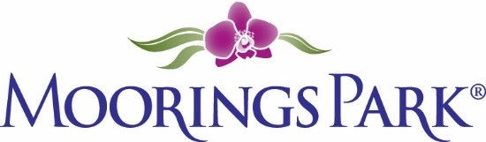
Moorings Park Weekly Progress Report Agenda
2/18/2022
Training Content | Complete | In Progress | Detail
- Shared updates and needs from both MP and CLI teams |  | X | CLI: New cover  William review  Steve review  https://www.corplearning.com/mp-csp/  MP:
- Review of all modules |  | X | To be shared at meeting
- Agenda reviews |  | X | Add questions from the team
- Program delivery dates options  - Printing questions |  | X | To be completed next week
- Looking ahead |  |  | Next steps for CLI

