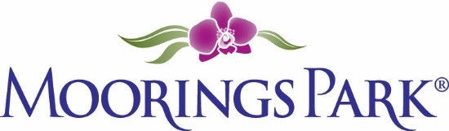
Moorings Park Weekly Progress Report Agenda
2/11/2022
Training Content | Complete | In Progress | Detail
- Shared updates and needs from both MP and CLI teams |  | X | William review  https://www.corplearning.com/mp-csp/  MP: Schedule update  CLI Housing  Lassie Update
- MODS 1 and 2 up for review |  | X | To be shared at meeting
- Classroom materials up for review | X |  | To be shared at meeting
- Manager Training |  | X | To be completed next week
- Next up |  |  | Next steps for CLI

