The New Gold Standard Outline
Joseph A. Michelli
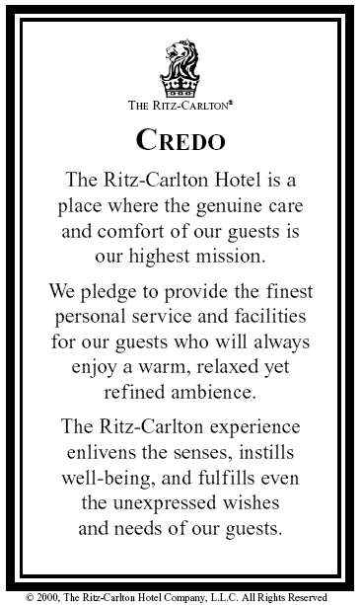
The Credo
The Ritz-Carlton is a place where the genuine care and comfort of our guests is our highest mission.
We pledge to provide the finest personal service and facilities for our guests who will always enjoy a warm, relaxed, yet refined ambience.
The Ritz-Carlton experience enlivens the senses, instills well-being, and fulfills even the unexpressed wishes and needs of our guests.

Motto
At The Ritz-Carlton Hotel Company, L.L.C., "We are Ladies and Gentlemen serving Ladies and Gentlemen." This motto exemplifies the anticipatory service provided by all staff members.

Three Steps of Service
- A warm and sincere greeting.
- Use the guest's name. Anticipation and fulfillment of each guest's needs.
- Fond farewell. Give a warm good-bye- make eye contact and use the guest's name.

Service Values: I Am Proud to be Ritz-Carlton
- I build strong relationships and create Ritz-Carlton guests for life.
- I am always responsive to the expressed and unexpressed wishes and needs of our guests.
- I am empowered to create unique, memorable and personal experiences for our guests.
- I understand my role in achieving the Key Success Factors, embracing Community Footprints and creating The Ritz-Carlton Mystique.
- I continuously seek opportunities to innovate and improve The Ritz-Carlton experience.
- I own and immediately resolve guest problems.
- I create a work environment of teamwork and lateral service so that the needs of our guests and each other are met.
- I have the opportunity to continuously learn and grow.
- I am involved in the planning of the work that affects me.
- I am proud of my professional appearance, language and behavior.
- I protect the privacy and security of our guests, my fellow employees and the company's confidential information and assets.
- I am responsible for uncompromising levels of cleanliness and creating a safe and accident-free environment.

The 6th Diamond
Mystique
Emotional Engagement
Functional

The Employee Promise
At The Ritz-Carlton, our Ladies and Gentlemen are the most important resource in our service commitment to our guests.
By applying the principles of trust, honesty, respect, integrity, and commitment, we nurture and maximize talent to the benefit of each individual and the company.
The Ritz-Carlton fosters a work environment where diversity is valued, quality of life is enhanced, individual aspirations are fulfilled, and The Ritz-Carlton Mystique is strengthened.

Daily Lineup

Much like a “team huddle”, the Ritz-Carlton Lineup is the system-wide 15-minute gathering of employees every morning in their departments. The Lineup schedule is standard throughout the company; five minutes discussing what is happening at the corporate level, another five minutes talking about their hotel events and gatherings of the day and week and important guests arriving, and finally five minutes reviewing one of the Gold Standards 20 Basics.

The Lineup may be the company’s most important tool in maintaining their superior service standards. Donavan tells us, “Good working relationships require communication. The Lineup allows daily communication and maintains a sense of purpose for all employees.” It is truly the company adhesive and bond as all 25,000 Ritz-Carlton employees worldwide are doing the same Lineup in their locales.

As department team members gather, a prepared agenda is used to reinforce service values and define the Ritz-Carlton culture and message. “Companies with the best and strongest corporate culture push it every day. You cannot control every employee/guest experience but in the Lineup, we can influence it,” says Donavan.

The Lineup is also used to reinforce the company’s long-standing principle of employee empowerment. Employees cannot evade difficult situations by muttering, “It’s not my job.” In the Lineup, Ritz-Carlton team members are reminded that job descriptions are irrelevant when guest satisfaction is at risk. Even a new employee can commit up to $2,000 of the hotel’s dollars to quickly resolve a guest concern! That is one of the fundamentals of the world-class service provided by the Ritz-Carlton Ladies and Gentlemen. “The line-up is our daily commercial to the employees,” Donavan notes. “The message of service and the review of our core values create the human beings responsible for the Ritz-Carlton mystique.”
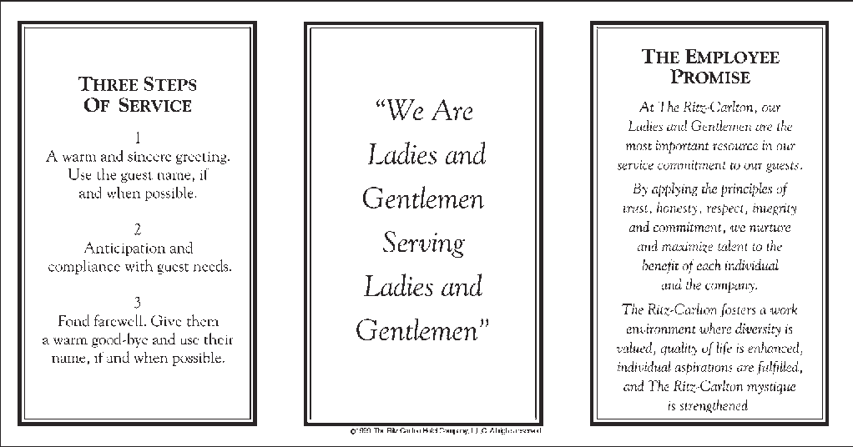

Service Values 1-6 I am proud to be Ritz-Carlton
I build strong relationships and create Ritz-Carlton guests for life. I am always responsive to the expressed and unexpressed wishes and needs of our guests. I am empowered to create unique, memorable and personal experiences for our guests. I understand my role in achieving the Key Success Factors and creating The Ritz-Carlton Mystique. I continuously seek opportunities to innovate and improve The Ritz-Carlton experience. I own and immediately resolve guest problems.
Service Values 7-12 I am proud to be Ritz-Carlton
I create a work environment of teamwork and lateral service so that the needs of our guests and each other are met. I have the opportunity to continuously learn and grow. I am involved in the planning of the work that affects me. I am proud of my professional appearance, language and behavior. I protect the privacy and security of our guests, my fellow employees and the company's confidential information and assets. I am responsible for uncompromising levels of cleanliness and creating a safe and accident-free environment.
Guest Relations Standards
Never lose a guest – Instant guest pacification is the responsibility of each employee – whoever receives a complaint will own it, resolve it to the guest’s satisfaction. Escort guests rather pointing out directions to another area of the Hotel
Customer Delight
To create loyal customers one must have a keen understanding of the customers and fulfilling their desires: “Remember me.“ Know what I want”. “Know how I want it”
3 Components of Employee Empowerment
Know what they are supposed to do
Know how well they are doing
Authority to make changes

Basic Empowerment Process
Warm Welcome
Employee Senses Guest Wish or Need
Employee Breaks away from Routine Duties
Employee Applies Immediate Positive Action
Determine Guest Reaction-Dissatisfied or Guest Needs Satisfied
Escalate the Complaint
Fond Farewell
Document the Incident
Employee Returns to Routine Duties
Guest Memory System
Results of Empowerment
Each employee has access to an account to provide the magnificent customer service each guest expects
Guests remark that they are: “Pampered” “Respected” “Treated like Royalty”
Smile we are on Stage
Always maintain positive eye contact
Use proper vocabulary with our guests and each other
Use words like: Good Morning, Certainly, I’ll be happy to, My pleasure”

The Ritz-Carlton Mystique

The Ritz-Carlton “mystique” is more than a vague or ambiguous aura. It is the message that the employees, and ultimately all customers and vendors, proclaim about the hotel’s services and facilities throughout the world. It is the buzz about those customer services that are always delivered with such style and dedication that makes the accompanying employee declaration, “It’s my pleasure.” ring true and genuine.

These constant praises, the “mystique” about the Ritz-Carlton, has minimized the need for print and other advertising as satisfied guests and employees provide sufficient acclaim and recommendation!

How to Measure Employee Engagement with the Q¹²
There are 12 needs managers can meet to improve employees' productivity. This approach to engagement is simple, and it works. These are the 12 employee needs that make up the items on Gallup's engagement survey:
- I know what is expected of me at work.
- I have the materials and equipment I need to do my work right.
- At work, I have the opportunity to do what I do best every day.
- In the last seven days, I have received recognition or praise for doing good work.
- My supervisor, or someone at work, seems to care about me as a person.
- There is someone at work who encourages my development.
- At work, my opinions seem to count.
- The mission or purpose of my company makes me feel my job is important.
- My associates or fellow employees are committed to doing quality work.
- I have a best friend at work.
- In the last six months, someone at work has talked to me about my progress.
- This last year, I have had opportunities at work to learn and grow.

Notes:

