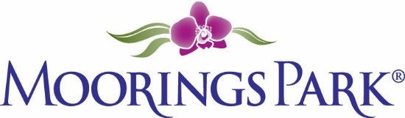
Moorings Park Weekly Progress Report Agenda
1/28/2022
Training Content | Complete | In Progress | Detail
- Shared Updates and Needs From Both MP and CLI Teams |  | X | MP:  CLI: Training Dates  https://www.corplearning.com/mp-csp/
2. Review to date of Empowerment Module |  | X
3. Review of Calendar |  | X
4. Start of Program Design with Debi |  | X | To be shared at meeting

