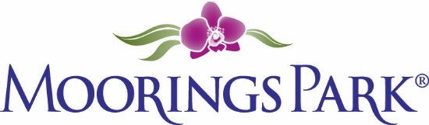
Moorings Park Weekly Progress Report Agenda
01/21/2022
Training Content | Complete | In Progress | Detail
- Shared updates and needs from both MP and CLI teams |  | X | MP:  CLI: Moved more content to new page—let’s look!  https://www.corplearning.com/mp-csp/
2. Frontline partners survey review | X |  | To be shared at meeting/in shared site
3. New book outline: The New Gold Standards |  | X | To be shared at meeting
4. Options for training delivery—blocking time |  | X | To be shared at meeting/in shared site
5. Major training themes discussion |  | X | To be shared at meeting/in shared site

