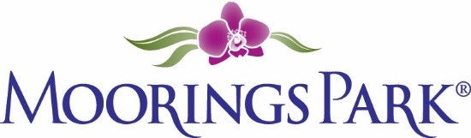
Moorings Park Weekly Progress Report Agenda
01/14/2022
Training Content | Complete | In Progress | Detail
- Shared updates and needs from both MP and CLI teams |  | X | MP:  CLI: Moved content to new page—let’s look!  https://www.corplearning.com/mp-csp/
2. Frontline partners survey launch update |  | X | To be shared at meeting/in shared site
3. Candidate for French Creole translation |  | X | To be shared at meeting
4. Project timeline completed | X |  | To be shared at meeting/in shared site
5. Three book reviews | X |  | To be shared at meeting/in shared site
6. Dan Lavender feedback | X |  | To be shared at meeting/in shared site
7. Options for training delivery |  | X

