Quotes for Effective Huddles

“I define a leader as anyone who takes responsibility for finding the potential in people and processes, and who has the courage to develop that potential.”
― Brené Brown, Dare to Lead: Brave Work. Tough Conversations. Whole Hearts.

“At the end of the day, at the end of the week, at the end of my life, I want to say I contributed more than I criticized.”
― Brené Brown, Dare to Lead: Brave Work. Tough Conversations. Whole Hearts.

“The courage to be vulnerable is not about winning or losing, it’s about the courage to show up when you can’t predict or control the outcome.”
― Brené Brown, Dare to Lead: Brave Work. Tough Conversations. Whole Hearts.

“Clear is kind. Unclear is unkind.”
― Brené Brown, Dare to Lead: Brave Work. Tough Conversations. Whole Hearts.

“Show up for people in pain and don’t look away.”
― Brené Brown, Dare to Lead: Brave Work. Tough Conversations. Whole Hearts.

“People are opting out of vital conversations about diversity and inclusivity because they fear looking wrong, saying something wrong, or being wrong. Choosing our own comfort over hard conversations is the epitome of privilege, and it corrodes trust and moves us away from meaningful and lasting change.”
― Brené Brown, Dare to Lead: Brave Work. Tough Conversations. Whole Hearts.

“If we want people to fully show up, to bring their whole selves including their unarmored, whole hearts—so that we can innovate, solve problems, and serve people—we have to be vigilant about creating a culture in which people feel safe, seen, heard, and respected.”
― Brené Brown, Dare to Lead: Brave Work. Tough Conversations. Whole Hearts.

“It is not the critic who counts; not the man who points out how the strong man stumbles, or where the doer of deeds could have done them better. The credit belongs to the man who is actually in the arena, whose face is marred by dust and sweat and blood; who strives valiantly; who errs, who comes short again and again…who at the best knows in the end the triumph of high achievement, and who at the worst, if he fails, at least fails while daring greatly.”
― Brené Brown, Dare to Lead: Brave Work. Tough Conversations. Whole Hearts.

“If you are not in the arena getting your ass kicked on occasion, I’m not interested in or open to your feedback. There are a million cheap seats in the world today filled with people who will never be brave with their lives but who will spend every ounce of energy they have hurling advice and judgment at those who dare greatly. Their only contributions are criticism, cynicism, and fearmongering. If you’re criticizing from a place where you’re not also putting yourself on the line, I’m not interested in what you have to say.”
― Brené Brown, Dare to Lead: Brave Work. Tough Conversations. Whole Hearts.

“The only thing I know for sure after all of this research is that if you’re going to dare greatly, you’re going to get your ass kicked at some point. If you choose courage, you will absolutely know failure, disappointment, setback, even heartbreak. That’s why we call it courage. That’s why it’s so rare.”
― Brené Brown, Dare to Lead: Brave Work. Tough Conversations. Whole Hearts.

“We fail the minute we let someone else define success for us.”
― Brené Brown, Dare to Lead: Brave Work. Tough Conversations. Whole Hearts.

“Only when diverse perspectives are included, respected, and valued can we start to get a full picture of the world:”
― Brené Brown, Dare to Lead: Brave Work. Tough Conversations. Whole Hearts.

“Daring leaders work to make sure people can be themselves and feel a sense of belonging.”
― Brené Brown, Dare to Lead: Brave Work. Tough Conversations. Whole Hearts.

“Feeding people half-truths or bullshit to make them feel better (which is almost always about making ourselves feel more comfortable) is unkind”
― Brené Brown, Dare to Lead: Brave Work. Tough Conversations. Whole Hearts.

“To be the person who we long to be—we must again be vulnerable. We must take off the armor, put down the weapons, show up, and let ourselves be seen.”
― Brené Brown, Dare to Lead: Brave Work. Tough Conversations. Whole Hearts.

“Rather than spending a reasonable amount of time proactively acknowledging and addressing the fears and feelings that show up during change and upheaval, we spend an unreasonable amount of time managing problematic behaviors.”
― Brené Brown, Dare to Lead: Brave Work. Tough Conversations. Whole Hearts.

“The Ham-Foldover Debacle:.....you make yourself the center of something that has nothing to do with you, out of your own fear or scarcity, only to be reminded that you're not the axis over which the world turns”
― Brené Brown, Dare to Lead

“Live BIG (boundaries, integrity, and generosity).”
― Brené Brown, Dare to Lead: Brave Work. Tough Conversations. Whole Hearts.

“Neuroscientist Antonio Damasio reminds us, “We are not necessarily thinking machines. We are feeling machines that think.”
― Brené Brown, Dare to Lead: Brave Work. Tough Conversations. Whole Hearts.

“We are not here to fit in, be well balanced, or provide exemples for others. We are here to be eccentric, different, perhaps strange, perhaps merely to add our small piece, our little clunky, chunky selves, to the great mosaic of being. As the Gods intended, we are here to become more and more ourselves.”
― Brené Brown, Dare to Lead: Brave Work. Tough Conversations. Whole Hearts.

“Don't grab hurtful comments and pull them close to you by rereading them and ruminating on them. Don't play with them by rehearsing your badass comeback. And whatever you do, don't pull hatefulness close to your heart.

“So often, when someone is in pain, we’re afraid to say, “Yes, this hurts. Yes, this is a big deal. Yes, this sucks.” We think our job is to make things better, so we minimize the pain.”
― Brené Brown, Dare to Lead: Brave Work. Tough Conversations. Whole Hearts.

“If you have more than three priorities, you have no priorities”
― Brené Brown, Dare to Lead: Brave Work. Tough Conversations. Whole Hearts.

“Trust is in fact earned in the smallest of moments.”
― Brené Brown, Dare to Lead: Brave Work. Tough Conversations. Whole Hearts.

“Choose courage over comfort”
― Brené Brown, Dare to Lead: Brave Work. Tough Conversations. Whole Hearts.

“For me, that strong back is grounded confidence and boundaries. The soft front is staying vulnerable and curious. The mark of a wild heart is living out these paradoxes in our lives and not giving into the either/or BS that reduces us. It’s showing up in our vulnerability and our courage, and, above all else, being both fierce and kind.”
― Brené Brown, Dare to Lead: Brave Work. Tough Conversations. Whole Hearts.

Let what's unproductive and hurtful drop at the feet of your unarmored self. And no matter how much your self-doubt wants to scoop up the criticism and snuggle with the negativity so it can confirm its worst fears, or how eager the shame gremlins are to use the hurt to fortify your armor, take a deep breath and find the strength to leave what's mean-spirited on the ground. You don't even need to stomp it or kick it away.
Cruelty is cheap, easy, and chickenshit. It doesn't deserve your energy or engagement. Just step over the comments and keep daring, always remembering that armor is too heavy a price to pay to engage with cheap-seat feedback.”
― Brené Brown, Dare to Lead

“No trust, no connection.”
― Brené Brown, Dare to Lead: Brave Work. Tough Conversations. Whole Hearts.

“Diminishing trust caused by a lack of connection and empathy.”
― Brené Brown, Dare to Lead: Brave Work. Tough Conversations. Whole Hearts.

“In either case, if you come across an explanation of vulnerability that doesn’t include setting boundaries or being clear on intentions, proceed with caution. Vulnerability for vulnerability’s sake is not effective, useful, or smart.”
― Brené Brown, Dare to Lead: Brave Work. Tough Conversations. Whole Hearts.

"Spread love everywhere you go. Let no one ever come to you without leaving happier." -Mother Teresa
2. "When you reach the end of your rope, tie a knot in it and hang on." -Franklin D. Roosevelt
3. "Always remember that you are absolutely unique. Just like everyone else." -Margaret Mead
4. "Don't judge each day by the harvest you reap but by the seeds that you plant." -Robert Louis Stevenson
5. "The future belongs to those who believe in the beauty of their dreams." -Eleanor Roosevelt
6. "Tell me and I forget. Teach me and I remember. Involve me and I learn." -Benjamin Franklin
7. "The best and most beautiful things in the world cannot be seen or even touched - they must be felt with the heart." -Helen Keller
8. "It is during our darkest moments that we must focus to see the light." -Aristotle
9. "Whoever is happy will make others happy too." -Anne Frank
10. "Do not go where the path may lead, go instead where there is no path and leave a trail." -Ralph Waldo Emerson
11. "If life were predictable it would cease to be life and be without flavor." -Eleanor Roosevelt
12. "In the end, it's not the years in your life that count. It's the life in your years." -Abraham Lincoln
13. "Life is a succession of lessons which must be lived to be understood." -Ralph Waldo Emerson
14. "You will face many defeats in life, but never let yourself be defeated." -Maya Angelou
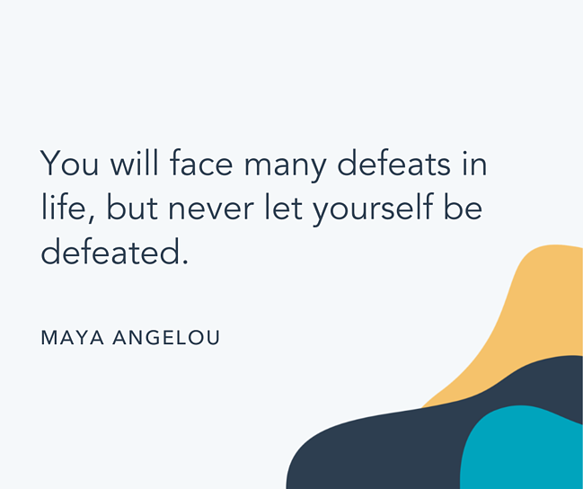15. "Never let the fear of striking out keep you from playing the game." -Babe Ruth
16. "Life is never fair, and perhaps it is a good thing for most of us that it is not." -Oscar Wilde
17. "The only impossible journey is the one you never begin." -Tony Robbins
18. "In this life we cannot do great things. We can only do small things with great love." -Mother Teresa
19. "Only a life lived for others is a life worthwhile." -Albert Einstein
20. "The purpose of our lives is to be happy." -Dalai Lama
21. "Life is what happens when you're busy making other plans." -John Lennon
22. "You only live once, but if you do it right, once is enough." -Mae West
23. "Live in the sunshine, swim the sea, drink the wild air." -Ralph Waldo Emerson
24. "Go confidently in the direction of your dreams! Live the life you've imagined." -Henry David Thoreau
25. "The greatest glory in living lies not in never falling, but in rising every time we fall." -Nelson Mandela
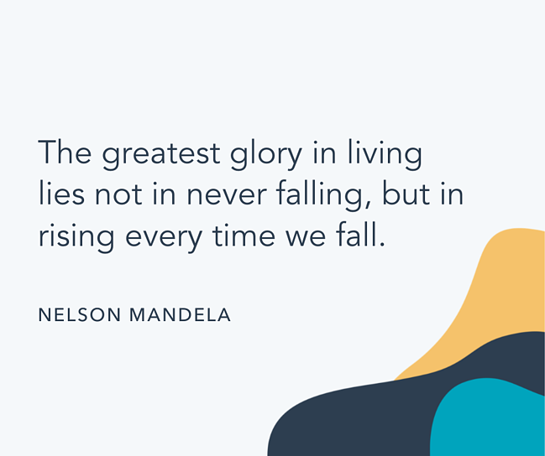26. "Life is really simple, but we insist on making it complicated." -Confucius
27. "May you live all the days of your life." -Jonathan Swift
28. "Life itself is the most wonderful fairy tale." -Hans Christian Andersen
29. "Do not let making a living prevent you from making a life." -John Wooden
30. "Life is ours to be spent, not to be saved." -D. H. Lawrence
31. "Keep smiling, because life is a beautiful thing and there's so much to smile about." -Marilyn Monroe
32. "Life is a long lesson in humility." -James M. Barrie
33. "In three words I can sum up everything I've learned about life: it goes on." -Robert Frost
34. "Love the life you live. Live the life you love." -Bob Marley
35. "Life is either a daring adventure or nothing at all." -Helen Keller
36. "You have brains in your head. You have feet in your shoes. You can steer yourself any direction you choose." -Dr. Seuss
37. "Life is made of ever so many partings welded together." -Charles Dickens
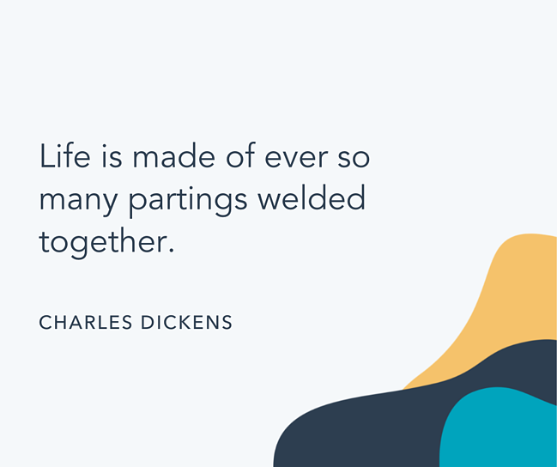38. "Your time is limited, so don't waste it living someone else's life. Don't be trapped by dogma — which is living with the results of other people's thinking." -Steve Jobs
39. "Life is trying things to see if they work." -Ray Bradbury
40. "Many of life's failures are people who did not realize how close they were to success when they gave up." -Thomas A. Edison
41. "The secret of success is to do the common thing uncommonly well." -John D. Rockefeller Jr.
42. "I find that the harder I work, the more luck I seem to have." -Thomas Jefferson
43. "Success is not final; failure is not fatal: It is the courage to continue that counts." -Winston S. Churchill
44. "The way to get started is to quit talking and begin doing." -Walt Disney
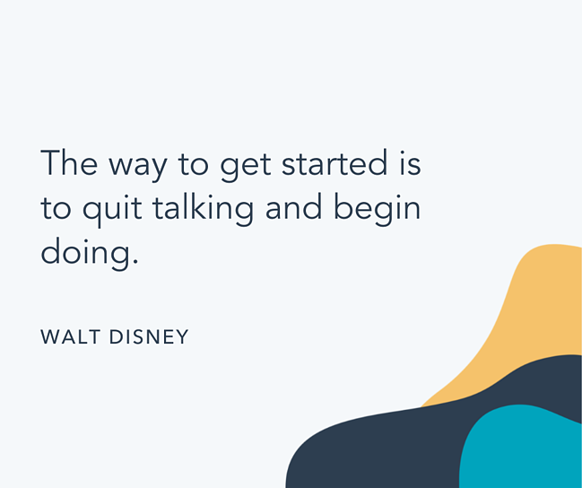45. "Don't be distracted by criticism. Remember — the only taste of success some people get is to take a bite out of you." -Zig Ziglar
46. "Success usually comes to those who are too busy to be looking for it." -Henry David Thoreau
47. "I never dreamed about success, I worked for it." -Estee Lauder
48. "Success seems to be connected with action. Successful people keep moving. They make mistakes but they don't quit." -Conrad Hilton
49. "There are no secrets to success. It is the result of preparation, hard work, and learning from failure." -Colin Powell
50. "The real test is not whether you avoid this failure, because you won't. It's whether you let it harden or shame you into inaction, or whether you learn from it; whether you choose to persevere." -Barack Obama
51. "The only limit to our realization of tomorrow will be our doubts of today." -Franklin D. Roosevelt
52. "It is better to fail in originality than to succeed in imitation." -Herman Melville
53. "Successful people do what unsuccessful people are not willing to do. Don't wish it were easier; wish you were better." -Jim Rohn
54. "The road to success and the road to failure are almost exactly the same." -Colin R. Davis
55. "I failed my way to success." -Thomas Edison
56. "If you set your goals ridiculously high and it's a failure, you will fail above everyone else's success." -James Cameron
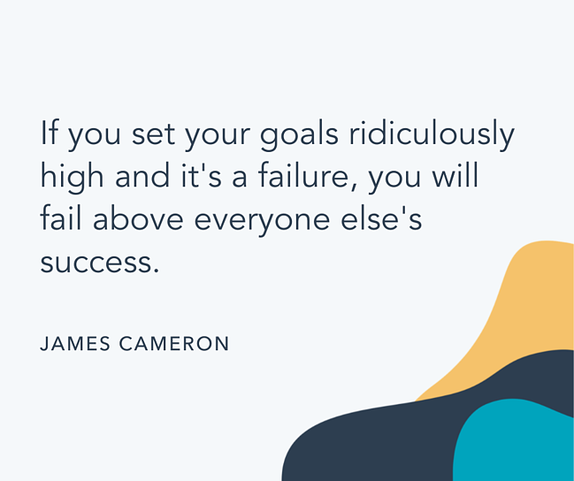57. "If you really look closely, most overnight successes took a long time." -Steve Jobs
58. "A successful man is one who can lay a firm foundation with the bricks others have thrown at him." -David Brinkley
59. "Things work out best for those who make the best of how things work out." -John Wooden
60. "Try not to become a man of success. Rather become a man of value." -Albert Einstein
61. "Don't be afraid to give up the good to go for the great." -John D. Rockefeller
62. "Always bear in mind that your own resolution to success is more important than any other one thing." -Abraham Lincoln
63. "Success is walking from failure to failure with no loss of enthusiasm." -Winston Churchill
64. "You know you are on the road to success if you would do your job and not be paid for it." -Oprah Winfrey
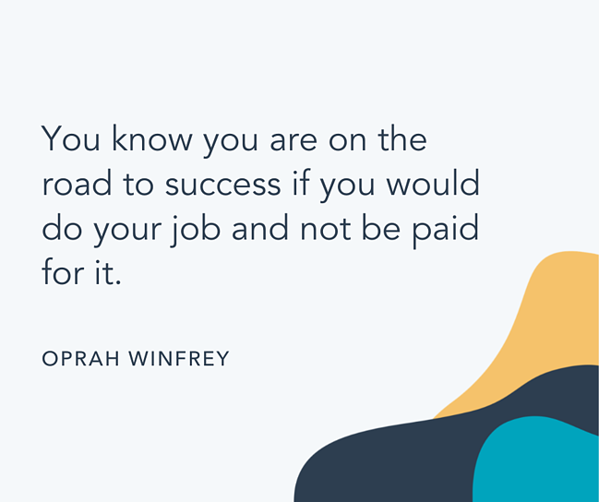65. "If you want to achieve excellence, you can get there today. As of this second, quit doing less-than-excellent work." -Thomas J. Watson
66. "If you genuinely want something, don't wait for it — teach yourself to be impatient." -Gurbaksh Chahal
67. "The only place where success comes before work is in the dictionary." -Vidal Sassoon
68. "If you are not willing to risk the usual, you will have to settle for the ordinary." -Jim Rohn
69. "Before anything else, preparation is the key to success." -Alexander Graham Bell
70. "People who succeed have momentum. The more they succeed, the more they want to succeed and the more they find a way to succeed. Similarly, when someone is failing, the tendency is to get on a downward spiral that can even become a self-fulfilling prophecy." -Tony Robbins
71. "Believe you can and you're halfway there." -Theodore Roosevelt
72. "The only person you are destined to become is the person you decide to be." -Ralph Waldo Emerson
73. "I've learned that people will forget what you said, people will forget what you did, but people will never forget how you made them feel." -Maya Angelou
74. "The question isn't who is going to let me; it's who is going to stop me." -Ayn Rand
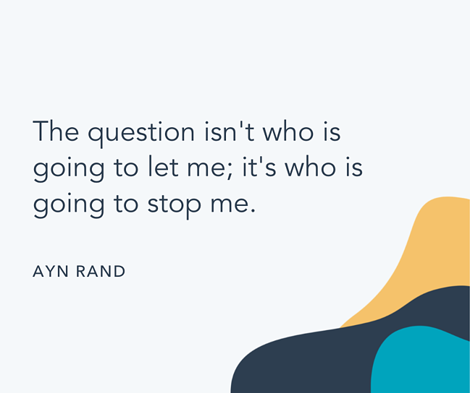75. "Winning isn't everything, but wanting to win is." -Vince Lombardi
76. "Whether you think you can or you think you can't, you're right." -Henry Ford
77. "You miss 100% of the shots you don't take." -Wayne Gretzky
78. "I alone cannot change the world, but I can cast a stone across the water to create many ripples." -Mother Teresa
79. "You become what you believe." -Oprah Winfrey
80. "The most difficult thing is the decision to act, the rest is merely tenacity." -Amelia Earhart
81. "How wonderful it is that nobody need wait a single moment before starting to improve the world." -Anne Frank
82. "An unexamined life is not worth living." -Socrates
83. "Everything you've ever wanted is on the other side of fear." -George Addair
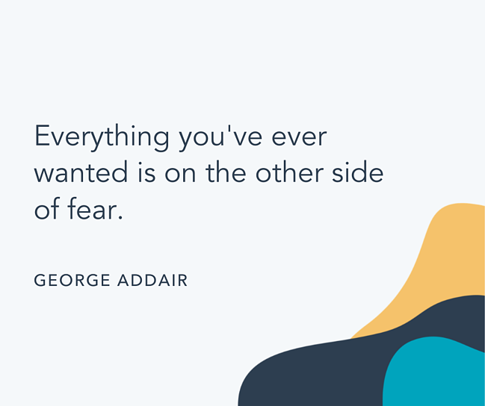84. "Dream big and dare to fail." -Norman Vaughan
85. "You may be disappointed if you fail, but you are doomed if you don't try." -Beverly Sills
86. "Life is 10% what happens to me and 90% of how I react to it." -Charles Swindoll
87. "Nothing is impossible, the word itself says, ‘I'm possible!'" -Audrey Hepburn
88. "It does not matter how slowly you go as long as you do not stop." -Confucius
89. "When everything seems to be going against you, remember that the airplane takes off against the wind, not with it." -Henry Ford
90. "Too many of us are not living our dreams because we are living our fears." -Les Brown
91. "I have learned over the years that when one's mind is made up, this diminishes fear." -Rosa Parks
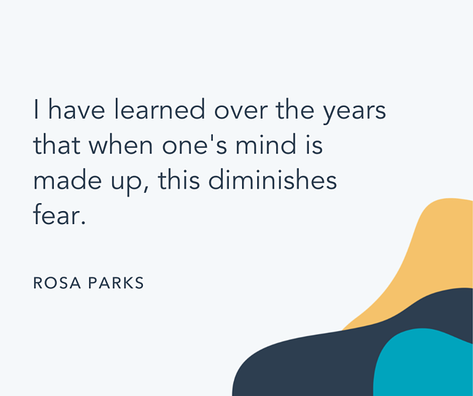92. "I didn't fail the test. I just found 100 ways to do it wrong." -Benjamin Franklin
93. "If you're offered a seat on a rocket ship, don't ask what seat! Just get on." -Sheryl Sandberg
94. "I attribute my success to this: I never gave or took any excuse." -Florence Nightingale
95. "I would rather die of passion than of boredom." -Vincent van Gogh
96. "If you look at what you have in life, you'll always have more. If you look at what you don't have in life, you'll never have enough." -Oprah Winfrey
97. "Dreaming, after all, is a form of planning." -Gloria Steinem
98. "Whatever the mind of man can conceive and believe, it can achieve." -Napoleon Hill
99. "First, have a definite, clear practical ideal; a goal, an objective. Second, have the necessary means to achieve your ends; wisdom, money, materials, and methods. Third, adjust all your means to that end." -Aristotle
100. "Twenty years from now you will be more disappointed by the things that you didn't do than by the ones you did do. So, throw off the bowlines, sail away from safe harbor, catch the trade winds in your sails. Explore, Dream, Discover." -Mark Twain

