TOGETHER We Make a Difference
Motivating Metrics: Five Clicks to Success

Example:
“How may certs were completed in Elite last week, and how can you improve?”

Note:
You must sign on to the SFHA network for the site to work.

- Go to http://nma-sql2017/Reports/browse/Occupancy%20Reports and click on “Completed Certs.”
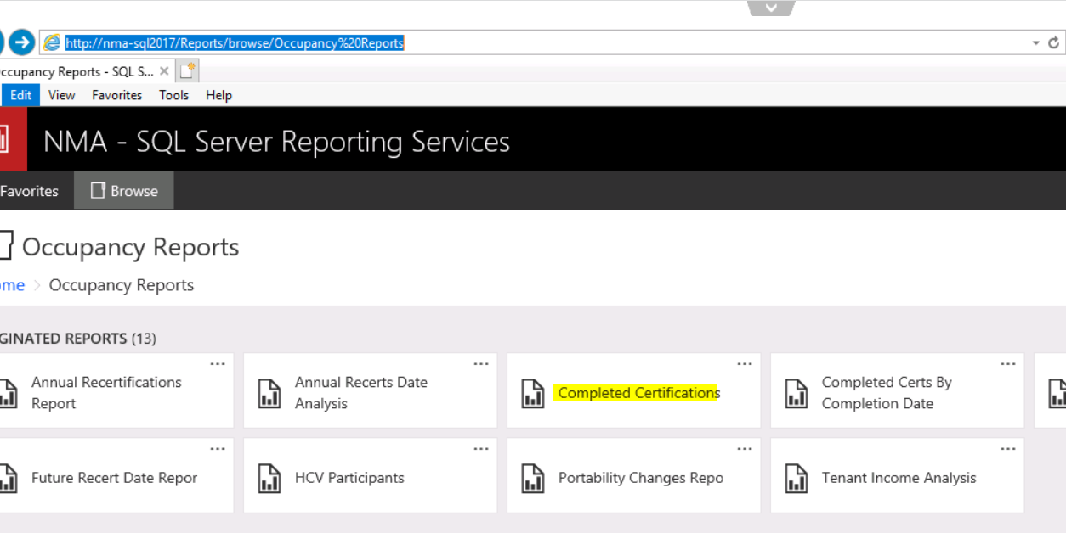

- Select the timeframe you are assessing and click view report.
See example below

- Download into Excel by clicking on the “Save” button and selecting “Excel”
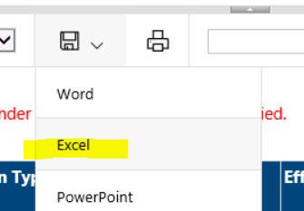

- Click on Insert-Pivot Table
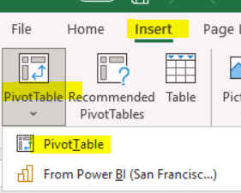

- From there you can filter by transaction and staff person. Use the overall numbers instead of individual performance numbers.
Say, “Look at our numbers here. Collectively we had a great week (highlight the big numbers) - what can we do to bring up the lower numbers? How can we work together to get these numbers up? Let’s make sure we are capturing the requests as they come in. Make sure you are updating SharePoint and ELITE.” See examples:

- The number processed by transaction type:
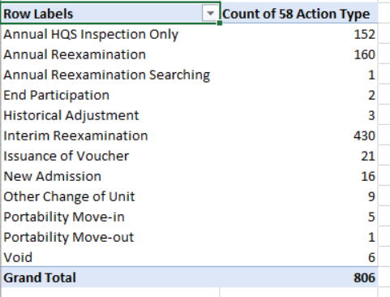
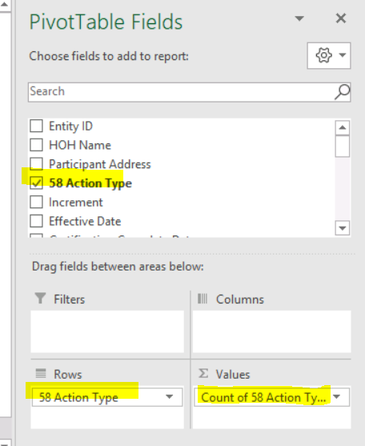

- The number processed by staff
