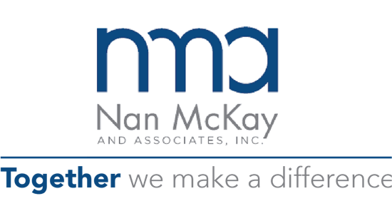

11-12-21

Hello Team,

I am excited to be part of your upcoming December 10, 2021, Leadership Team Offsite! I will be facilitating the Friday meeting focusing on team development and strategies for success.

I have created a learning portal called Learning Quest that you can access to review all the materials we will be using: https://www.corplearning.com/nma-learning-site/. On this site you will find all communication materials, program materials and pre-reading.

The offsite will kick-off the Together We Make a Difference Initiative, and will be a combination of learning models, activities, breakout conversations and large group discussions. The goals of the offsite are to have a more aligned and connected leadership team and to build a strategy to achieve your goals for 2022.

In preparation for our offsite we have a few pre-work items – see below:

- One-on-One Interview
I will have a one-on-one interview with each of you. The purpose of the interview is as follows:
- For us to get to know each other. I find this helps for a more effective offsite.
- To check-in on how you are doing as a contributor.
- To share the overall steps of the program.
- To review your DISC profile, strengths, and challenges.
- To answer any questions you may have.
- To review your responses to a short stress survey and provide support.
- To create a coaching action plan.
- The interviews are confidential and are mostly to prep me to effectively facilitate and to prepare each of you. I may share interview themes with the group if it makes sense.

- DISC Assessment
I will be sending you a link to take the DISC assessment. The DISC is a short assessment that measures the way you prefer to do things at work. The assessment will help the team understand how to leverage and support each team member.

- Stress Assessment
Please complete the Burnout Assessment, a learning tool, in your Learning Quest portal.

- Artifact
You will be asked to bring an “artifact” from home that helps us learn about what is important to you – a hobby, a life event, anything, or anyone that is a valuable part of your life. This can be anything legal that is not alive. Bring this item with you in a concealed bag and hand it to me when we meet at the start of the session.

If you want to know more about me checkout my LinkedIn Profile at https://www.linkedin.com/in/drcain/.

If you need to talk, just reach out to me at my contact information below. Thanks, and I look forward to seeing you all soon.

Dr. Sue Cain
630.347.6333
scain@corplearning.com
www.corplearning.com

