Inspired Reading for your Leadership Offsite
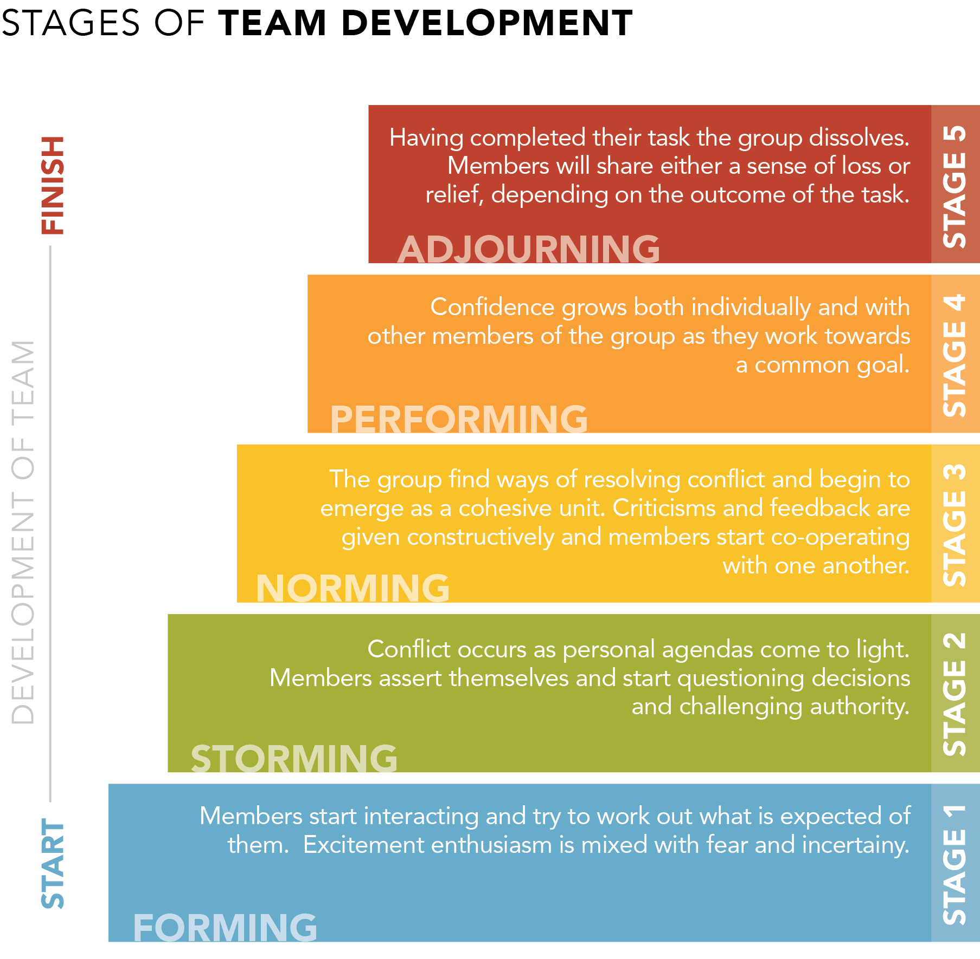

Questions to Ponder
1. Which stage most accurately describes your team currently?
2. What can be done and by whom to move the team toward the “performing” stage?

