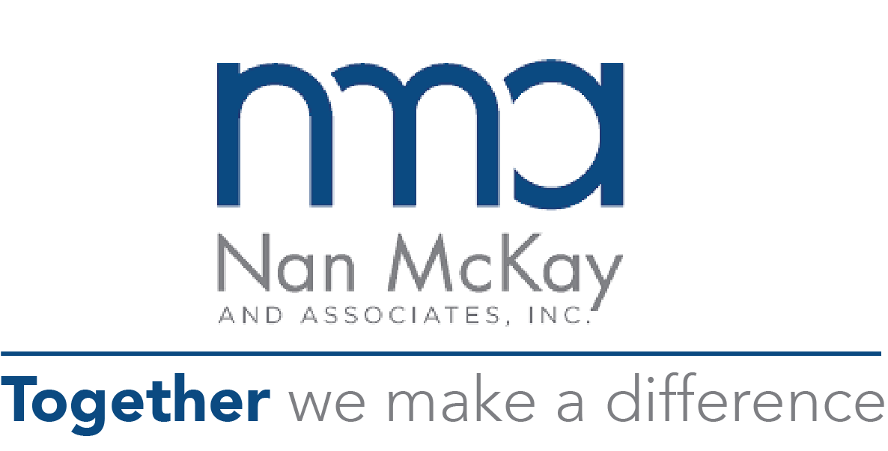
Inspired Reading for your Leadership Offsite
Self-Encouragement Bill of Rights

- It is OK to want or need something from someone else.
- I have a choice to ask someone for what I want or need.
- I can stand it if I don’t get what I want or need.
- If I didn’t get my objectives, that doesn’t mean I didn’t go about it in a skillful way.
- Standing up for myself over “small” things can be just as important as “big” things are to others.
- I can insist upon my rights and still be a good person.
- I sometimes have a right to assert myself, even though I may inconvenience others.
- The fact that other people might not be assertive doesn’t mean that I shouldn’t be.
- I can understand and validate another person, and still ask for what I want.
- There is no law that says other people’s opinions are more valid than mine.
- I may want to please people I care about, but I don’t have to please them all the time.
- Reality Statements for Boundary Setting and Interpersonal Effectiveness
- Giving, giving, giving is not the be-all of life. I am an important person in this world, too.
- If I refuse to do a favor for people, that doesn’t mean I don’t like them. They will probably understand that, too.
- I am under no obligation to say yes to people simply because they ask a favor of me.
- The fact that I say no to someone does not make me a selfish person.
- If I say no to people and they get angry, that does not mean that I should have said yes.
- I can still feel good about myself, even though someone else is annoyed with me.

Questions to Ponder:
1. Which statement(s) resonate with you most?
2. Which strike you as less valuable?

